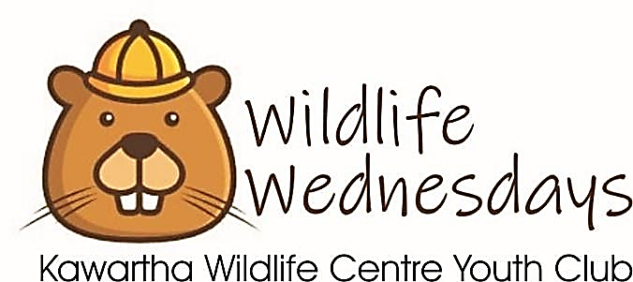

Welcome to Wildlife Wednesdays Youth Club!

The Kawartha Wildlife Centre is thrilled to offer an inclusive youth club for children between the ages of 6 and 11 years of age, every Wednesday evening from 6:30 – 8:00pm.
Wildlife Wednesdays Youth Club 2020 Registration Form

Wildlife Wednesdays Youth Club gives clubbers the opportunity to learn about wildlife habitat, conservation values and ways to be a wildlife HERO. Our programs offer animal and nature themed games, crafts and excursions to encourage kids to ask questions and challenge their understanding about nature and their place in it.

Today’s Date: Click here to enter a date.
2020 Wildlife Wednesday Club Sessions (Each session is 8 weeks)
☐ Spring Session: Wednesday April 29th – Wednesday June 17th
☐ Fall Session: Wednesday Sept 30th – Wednesday November 18th

Clubber Information: Please use the fillable boxes OR print clearly

What is your child’s favourite wild animal?
Full Name:
Birth Date:
Age:
Preferred Gender:
Health Card Number:
Family Doctor Name and Phone Number:
Medications:
Allergies:
**Please note: We can not guarantee to be a nut free centre as we do have nuts at the centre and may be using them to feed animals. Due to some of the outdoor activities, bee stings are also a risk.
Other Medical Concerns (e.g. seizures, pain):
Dietary Concerns: *we will be providing light snacks.
Additional Information: ** Please add all details on this form

Parent / Guardian Information:

- Parent/Legal Guardian Name:
Full Address:
Phone Number(s):
Email Address:

- Emergency Contact #1:
Phone Number(s):
Relationship to Clubber:

- Emergency Contact #2:
Phone Number(s):
Relationship to Clubber:

People Authorized to Drop Off/Pick Up Clubber (incl. relationship to clubber):

Club Information:
Wildlife Wednesdays Youth Club is located at the Kawartha Wildlife Centre at 470 Robinson Road in Ennismore. Each club session will be spent within the facility area (indoors and outdoors). Activities will feature wildlife crafts such as building bird, bat, and bee boxes; identification of local insects, birds, and mammals; wildlife journaling; gardening for wildlife; and conservation values.

Snacks: We are NOT a ‘Nut Free’ facility as we do have nuts for animal feed. We may be providing snacks as part of our program, please ensure that you identify any food concerns in your clubber’s medical information.

Drop off and Pick up:

Wildlife Wednesday Youth Club runs from 6:30pm and ends at 8:00pm. Kids may be dropped off as early as 6:20pm and must be picked up by 8:10pm. Late pickups will incur an additional charge of 10$ per day.

We want this youth club experience to be a positive one for all of our clubbers, leaders, and staff. The behaviour and personal condition of each clubber can affect us all, so...
● Kawartha Wildlife Centre reserves the right to refuse registration or attendance if it is decided that the child cannot be provided with a safe and enjoyable youth club experience.
● The Youth Club Director reserves the right to dismiss a clubber who, in his/her opinion, has displayed unacceptable behaviour and/or has not complied with the rules of the club. Club fees are non-refundable if a child is sent home for misbehaviour.
● Kawartha Wildlife Centre may collect and use audio-visual material and photographs of your clubber for publicity and promotional purposes. If you do not wish your child’s photo to be taken, please explicitly note this in the “Additional Information” section of this form.
● If an insufficient number of clubbers have registered for a session, that session may need to be suspended (with as much notice as possible). A full refund of fees will be returned in this case.
● Kawartha Wildlife Centre is not responsible for lost, damaged, or stolen items brought to the club.

Registration Submission:
☐ $50 each session (Spring/Fall) for each clubber
☐ $65 each session including T-Shirt for each clubber
Total Paid:
☐ Cash ☐ Debit ☐ Credit ☐ Online

**Registrations are not processed until payment is received - Delaying payment may result in space being unavailable in the case of full club sessions. Payments can be made online through our website, by credit over the phone, in person at the centre or by sending a cheque in the mail.

By checking the box below;
I understand and agree to the registration conditions, terms of service, and club behavioural expectations. I am stating that I am the legal parent/guardian of this clubber and that I have read, agree, and accept the Kawartha Wildlife registration conditions, behavioral expectations, and terms of service. I understand the activities my child will be participating in have some inherent risk of injury, known and unknown.
☐ I agree to the terms and conditions

Please submit your completed registration form to:
info@kawarthawildlifecentre.ca or by mail / drop off to:
Kawartha Wildlife Centre
470 Robinson Rd.
Unit B
Ennismore, ON
K0L 1T0

705-292-9211
info@kawarthawildlifecentre.ca

